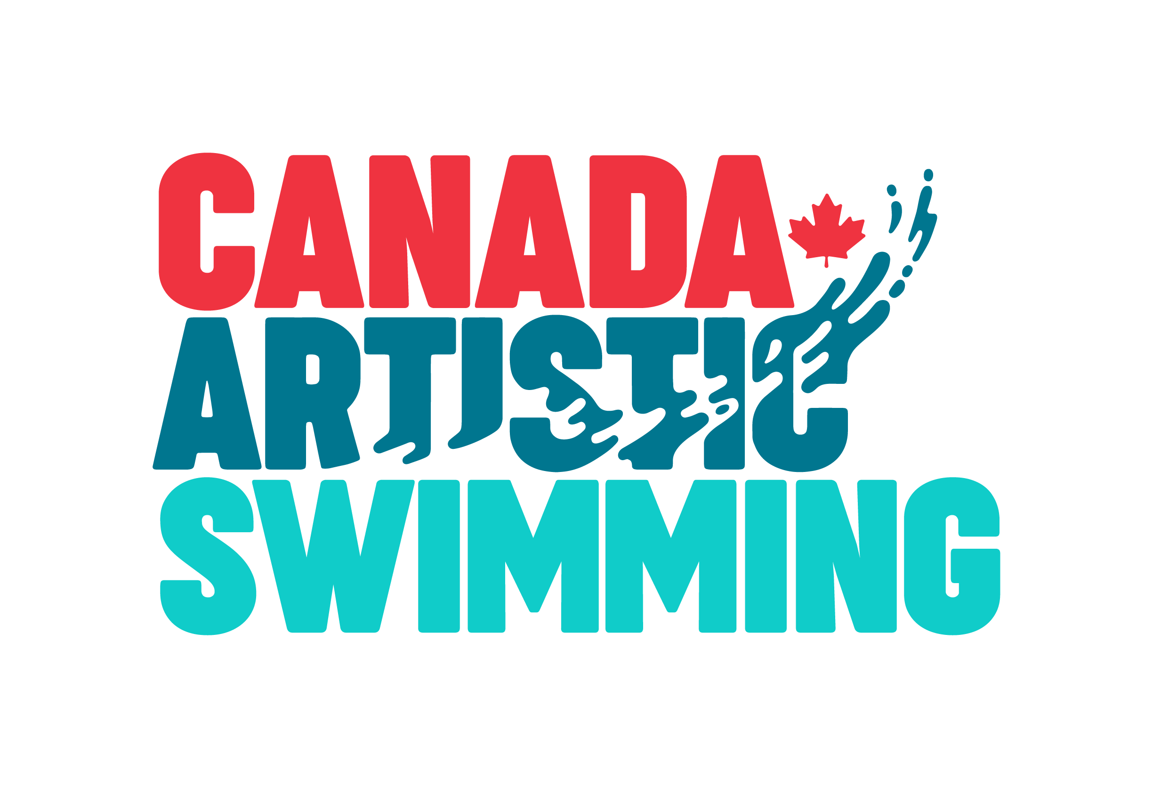
12U DEVELOPMENT SUMMER CAMP
PARTICIPANT INFORMATION FORM

Please fill out one form per athlete. Athletes aged 10 to 12 synchro age at the start of camp are eligible to register (birth year 2007, 2008, 2009).

Please provide your email address below to receive your registration confirmation and information!

IN ORDER FOR REGISTRATION FORMS TO BE PROCESSED ALL SECTIONS MUST BE COMPLETED, INCLUDING PAYMENT FOR CAMP.

ATHLETE INFORMATION:
LAST NAME: | FIRST NAME:
BIRTHDATE: (MM)/ (DD)/ (YY) |  | AGE:
ADDRESSE: | CITY:
MALE: FEMALE:
PARENT/ GUARDIAN INFORMATION:
- NAME: | EMAIL:
DAY PHONE #:
RELATIONSHIP TO CHILD:
- NAME: | EMAIL:
DAY PHONE #:
RELATIONSHIP TO CHILD:
EMERGENCY CONTACT INFORMATION (Other than parent; must be a resident of Ottawa/Gatineau)
NAME: | RELATIONSHIP:
CONTACT #: Work | Cell
EMERGENCY PICK-UP or ALTERNATE PICK UP
This is a person over the age of 16 who is authorized to pick up your child and can be contacted by Canada Artistic Swimming staff when the parent/guardian can’t be reached.
RELATIONSHIP:
LAST NAME: | FIRST NAME:
HOME PHONE: | WORK PHONE:
CELL PHONE:
Participants 11 years old and under must be signed in and signed out by a parent/guardian or a person over the age of 16. If your child is 12 or older does she/he have your permission to be released on their own at the end of their camp day?

YES NO
Parent/ Guardian Signature:

PHOTO RELEASE
During day camps, digital media may be taken for media or marketing purpose. If you are willing to have your child participate in film or photo opportunities please sign the image release below.
I agree to grant Canada Artistic Swimming permission to take and publish still photographs and moving videos, or publish those previously taken of my child. These pictures will be used by Canada Artistic Swimming for the purpose of displays and promotion only.
I give permission for my child’s photo to be taken
I do not give permission for my child’s photo to be taken
Parent/ Guardian Printed Name:

Parent/ Guardian Signature:

SWIMMING ABILITY

My child is able to swim well in deep water without aid YES NO

MEDICAL INFORMATION

Family Physician: Phone Number:
Canadian Health Care Number:

Does your child have any medical or behavioural conditions that we should be aware of? YES NO
If yes, please take a moment to explain:

Does your child use a puffer? YES NO

Carries Epi-Pen? YES NO For:
Wears medical alert bracelet: YES NO For:

Allergies:
Seasonal YES NO Medication:
Drugs: YES NO Medication:
Food: YES NO Medication:
Insect: YES NO Medication:
Other: YES NO explain:

Dietary needs or restrictions (please provide details below):
Gluten free Lactose intolerance Vegetarian Peanuts
Other:

Do you have any concerns about your child’s development? (please explain).
Does your child have concerns with the following? (Please check)
Physical: Vision, hearing, speech, nutrition, clumsiness, sleep,
other: please list:
Behaviour: Hyperactivity, Aggressive Behaviour, Shyness or Timidity,
Unhappiness, other: please list:

MEDICAL STATEMENT
In case of emergency or illness, every effort will be made to contact the parents or guardians. In the event that contact cannot be made, I agree that in case of emergency or illness, a qualified medical attendant may attend to my child.
I Agree I do not agree

Parent/Guardian Signature Date:

PAYMENT, CANCELLATIONS AND REFUND
You will receive confirmation of registration upon receipt of payment and of your completed forms. Full payment by Electronic Funds Transfer (EFT) is required with your online registration to reserve your child’s spot. If full payment is not received prior to the camp start date, Canada Artistic Swimming reserves the right to cancel the registration without notice, and cancellation charges will be applied. If you have not received your confirmation of registration via email following your online registration and payment, please contact Jennifer at jennifer@artisticswimming.ca to make sure your registration was received.
Requests for cancellations must be made in writing and submitted to Jennifer via email at via email at jennifer@artisticswimming.ca . No cancellation requests qualify for a refund, with the exception of a medical reason. A doctor’s note is required for cancellations and refund due to medical reasons.

I have read and understand the Payment, Cancellation and Refund Statement.
Signature:

POLICIES AND CONSENT
DISCLAIMER, AUTHORIZATION AND CONSENT:
Parent/Guardian Initial:
I ACKNOWLEDGE that my child's participation in the develop camp activities may involve certain health and safety risks. YES NO

By registering my child, I therefore AGREE to his/ her participation in activities and does so at his/her own risk and neither Canada Artistic Swimming, UniGym, Centre Sportif Gatineau, or its employees and contractors, nor its volunteers will be liable for any loss, damage or injury whatsoever that may occur during any part of his/her participation. If applicable, I undertake to inform Canada Artistic Swimming of any special medical condition of my child and his medical history. If my child has an accident or falls ill and Canada Artistic Swimming staff cannot contact the persons named on this form, I AUTHORIZE Canada Artistic Swimming staff to act for my child, in the event that an intervention is urgently needed.
YES NO

The participant or parent/guardian of the participant agrees to pay for any ambulance services required and authorizes the Centre Sportif de Gatineau to send participant directly to the hospital by ambulance at their discretion. YES NO

I AGREE TO inform Canada Artistic Swimming of any change in the health status and medical information of my child. YES NO
I certify that the all of the above information is current and accurate to the best of my knowledge.
Parent/Guardian:
Printed Name:

Parent/Guardian Signature :
Date:
Please save your document as per the following title :

Registration-<athletename>

Example : Registration-JenniferLanglois

And email to jennifer@artisticswimming.ca within 48 hours of completing your online registration and payment.

