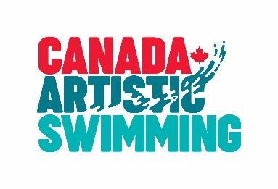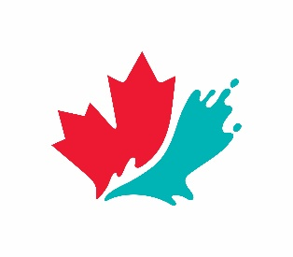

Board of Directors Nomination/ Application Form
July 2019

SEPTEMBER 2019 ELECTIONS

The outstanding success of Canada’s national artistic swimming teams stem from a solid membership base and the quality programming offered by Canada Artistic Swimming (CAS), the governing body of the sport in Canada.
CAS is looking for interested, qualified candidates to join its Board and help lead the organization.

The Board meets once a month approximately and as required. The meetings are held by telephone or in person. At its annual meeting, on September 14th 2019, CAS voting members will elect 2 directors to serve for a 2-year term and 2 directors to serve for a 3-year term.

NOMINATIONS

Persons interested in joining the CAS Board should complete the nomination form and attach a brief curriculum vitae. A brief statement is required as to why you wish to run for the position, your prospective contribution to delivering the CAS mission, along with your personal objectives as a Director, should you be elected.

Following consultation with the Board and other stakeholders, the Nominating Committee especially welcomes nominations from those who can strengthen CAS’s representation in the following areas of skills and expertise:
- Finance
- Technology
- Communication
- Change management
- Alumni relations and philanthropy
- Governance and board experience
- Experience or insight into multiple levels of artistic swimming (high performance, club, provincial sport organization, trainer…)
Section 28.5 of the Bylaws states that no more than two directors may reside in one Province or Territory.
CAS is committed to building a skilled, diverse Board reflective of Canadian society and of our sport community.

The application must be endorsed by one Canada Artistic Swimming registrant. This application (not the contact information page) will be shared with the voting delegates prior to the Annual Meeting.

PROCESS

The Nominating Committee will screen all nominations received to ensure that they meet the minimum qualifications required at law for a director (an individual, at least 18 years of age, with capacity and not bankrupt).

Nominations will then be reviewed and evaluated against the skills, expertise and diversity as provided for above. The Nominating Committee will make a list of recommended candidates and of qualified candidates.

ALL NOMINATION/APPLICATION FORMS (ENDORSED OR NOT) ARE DUE TO THE CANADA ARTISTIC SWIMMING NATIONAL OFFICE (ATTENTION CEO – jackie@artisticswimming.ca) NOT LATER THAN AUGUST 14, 2019, 17:00 ET.

Note: Thank you very much for your interest and application. Only those nominees/ applicants who are short listed will be contacted for an interview.

Contact Information of Applicant/Nominee

Name
Address
Cell Phone
Home Phone
Email
Social Media accounts

Board of Directors Nomination/ Application Form
July 2019
Personal Information
Name
Home Province
Gender (optional) | Male Female
Professional Designations
Diversity specificity (optional)
Principal Occupation

- Professional Experience – briefly list and describe your key employment history

- Volunteer Experience/History – list previous involvement with boards or committees and highlight key accomplishments

- Strengths and skills - State your three greatest strengths that you feel would contribute to the work of Canada Artistic Swimming’s National Board of Directors and indicate why (reference skills and attributes listed in call for nominations information)

- Governance – what do you think are the most important functions of the national board of directors of Canada Artistic Swimming?

Canada Not-for-profit Corporations Act: In accordance with the requirements of section 126 of the Canada Not-for-profit Corporations Act, I declare that

- I am older than 18 | YES | NO
- I am not personally bankrupt | YES | NO
- I have not been declared incapable by a court in Canada or another country | YES | NO
- I am currently registered with Canada Artistic Swimming | YES | NO

I hereby certify that the information I have provided is accurate and true.

___________________________________________________________
Signature of Applicant

_ _________________ _____________________ ___________________
Nominee/Applicant Name Nominee/Applicant Signature Date
(printed)

__________________ ______________________ ___________________
Witness Name Witness Signature Date

Note to all nominees/applicants: in order to accept a nomination for a position on the Canada Artistic Swimming Board of Directors you must be a registrant of Canada Artistic Swimming in good standing. If you are not currently a registrant, please attach a cheque for the $9.00 associate registrant fee payable to Canada Artistic Swimming.

Nominator Information and Authorization:

I hereby nominate and endorse __ ________________________________ as a candidate
(Name of Nominee/Applicant)

for election to the Canada Artistic Swimming Board of Directors at the 2019 Annual Meeting.

_________________ _______________________ ___________________
Canada Artistic Swimming Nominator Signature Date
Registrant Nominating this
Applicant

